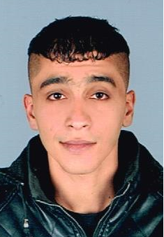

CV

HUSAIN ALI JASIM AHMED FADHUL

House 1088,road 4233,

Alduraz 542, kingdom of Bahrain

Mob: 36861763

Email:hussain_e30@icloud.com

Career objective

To purpose my career in a challenging and dynamic environment where my skills and

Capabilities could be most utilized & thereby

To become a part of success of the organization.

Personal Details

Date of birth :14/5/2001

Sex : male

Nationality : Bahraini

Marital status : single

CPR NO. : 010504222

Educational qualification

. Secondary school (field of electrical)

Work experience

. -TAKWEEN Training Program at Alkhajah Factoy

From 23-sep-2018 to 18 -Oct-2018.

I worked in AWAL GULF MANUFACTURING as a machine operator for 3 months.

Personal skills

. Self-motivated, hardworking, organized, logical and objective thinking, decision maker, Ability to

Dedicate in work, capable of handling duties and responsibilities independently and ability to deal with people easily.

Valid driving license

Language known

. English(Speaking and writing)

. Arabic(Speaking and writing)

Declaration

. All the information gives above are true to the best of my knowledge and Believe.